**Hardware Implementation**

**By Nahom Getaneh, Prince Nhliziyo**

The following materials were used on the implementation of the project.

Breakout PCB Raspberry Pi 3 b+

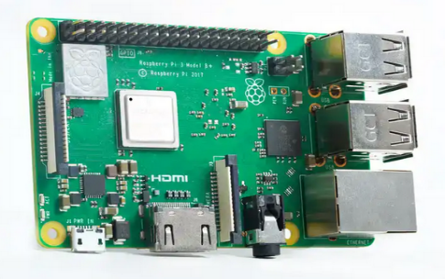

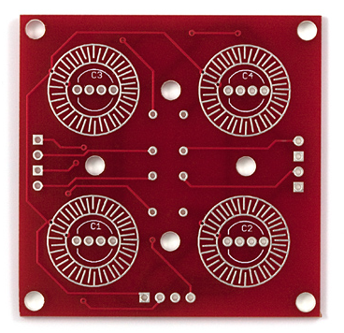

Male-to-female jumper wires RGB Cathode Diode(1N4148)

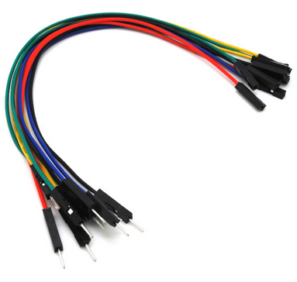

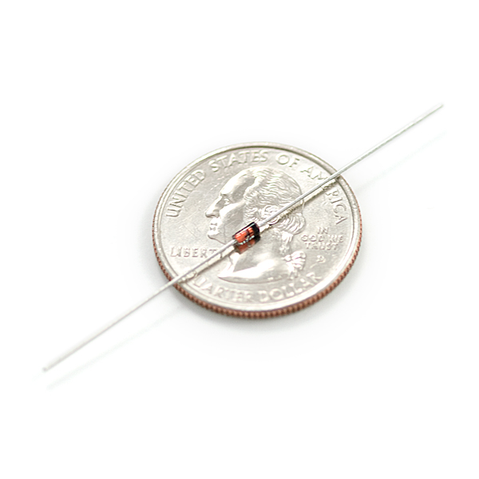

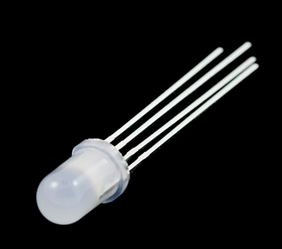

The first part of the hardware implementation involved testing all the components to make sure that they were working correctly. We had to solder several components to the breakout PCB board. These components include the 4 RGB LED light bulbs, the diode, and and also the 7 female-to-male jumper wires on the male side. We followed [this website](https://learn.sparkfun.com/tutorials/button-pad-hookup-guide?_ga=2.56267181.783550053.1558128612-779361050.1553546316) (<https://learn.sparkfun.com/tutorials/button-pad-hookup-guide?_ga=2.56267181.783550053.1558128612-779361050.1553546316>) instructions to solder the components on the PCB board. The female side of the jumper wires was plugged into the GPIO pins on the Raspberry Pi. The first table shows which GPIO pins we used and what they correspond to. The second table shows the wire colors we used and what they correspond to on the board.

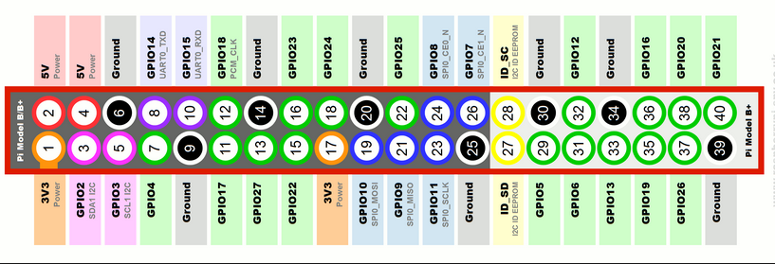

|  |  |
| --- | --- |
| **On Board** | **GPIO** |
| Red | 13 |
| Blue | 29 |
| Green | 15 |
| Led Ground 1/Blue | 36 |
| Led Ground 2/ Red LED | 12 |
| Led Ground 3/ Magenta LED | 33 |
| Led Ground 4/ Green LED | 7 |

|  |  |
| --- | --- |
| **On board** | **Wire** |
| Red | Red |
| blue | green |
| green | blue |
| Led gnd 1 | black |
| Led gnd 2 | gray |
| Led gnd 3 | orange |
| Led gnd 4 | white |

